# Code

function [y] = cell_growth(varargin)

% [y] = cell_growth(y0, h, xn)

% y0=Initial cell concentration

% h=time step size

% xn=maximum time

% y=A vector of values corresponding to the cell concentration

%Write your f(x,y) function, where dy/dx=f(x,y), x(x0)=y0.

switch nargin

case 3

meu=10e-1;

kd=1e-6;

y0=varargin(1);

h=varargin(2);

xn=varargin(3);

case 4

last=cell2mat(varargin(4));

disp(last)

meu=last(1);

kd=last(2);

y0=varargin(1);

h=varargin(2);

xn=varargin(3);

end

y0=y0{1};

h=h{1};

xn=xn{1};

f=@(x) meu*977*x-kd*x.^2;

% initial value of x0

x0=0;

% title of columns

fprintf('\n x y ');

y=[];

while x0<=xn

% update value

y1=y0+h*f(x0);

x1=x0+h;

x0=x1;

y0=y1;

%values of x and y

%print on command window

fprintf('\n%4d %4.1f ',x0,y0);

% x=[x x0];

% maintain all value in vector as output demand

y=[y y0];

end

end

# Output

## Case 01

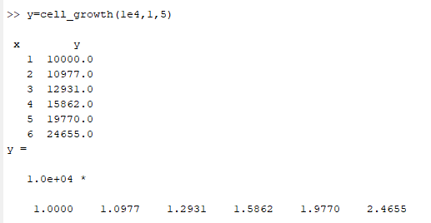

## Case 02

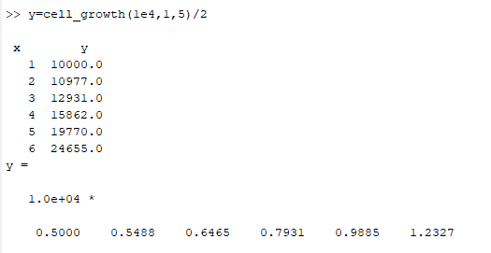

## Case 03

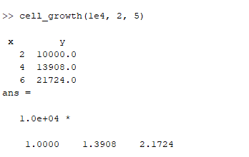

## Case 04

